Predicting Potential Burn Area of Active Forest Fires Using Geospatial Weather Forecasts

Kirankumar Manivannan
School of Electronics Engineering
Vellore Institute of Technology
Chennai, Tamil Nadu, India kiransun5@gmail.com
Riddhi Bandyopadhyay
School of Computer Science
Vellore Institute of Technology
Chennai,Tamil Nadu, India riddhi.b2022@vitstudent.ac.in
Sinchan Shetty
School of Computer Science
Vellore Institute of Technology
Chennai,Tamil Nadu, India
sinchan.nagaraj2022@vitstudent.ac.in
Satakshi Dalal
School of Computer Science
Vellore Institute of Technology
Chennai,Tamil Nadu, India
satakshi.dalal2022@vitstudent.ac.in

Abstract— Wildfires cause devastating environmental and economic damage. They do require advanced technologies for better response and resource management. This research work presents an AI-based prediction model for estimating the future area that may burn for the next 2 hours in an ongoing forest fire. The model uses the dataset of Montesinho Natural Park, the real-time geospatial satellite data acquired from API integration, and key environmental parameters like temperature, humidity, wind speed, and rainfall. Several machine learning algorithms, such as Random Forest, Linear Regression, XGBoost, Support Vector Machines (SVM), and Neural Networks, were evaluated based on Root Mean Square Error (RMSE) performance metric. Out of these, each Random Forest and XGBoost produced the best accuracy, with RMSE of 0.6138. It supports evidence-based decision-making towards efficient wildfire resource allocation and response planning, particularly in often fire-prone regions.
Keywords— wildfire, Machine learning, XGBoost, Random Forest regressor, API key

Introduction
Wildfires, the fierce fires of the forest, are an exceedingly destructive natural force that may leave a trail of devastation over the environment, cause economic loss, and take up human lives. These uncontrolled fires are often sparked through natural phenomena such as lightning and human activities such as deforestation, unattended campfires, and agricultural burning. Once ignited, a forest fire can grow into an inferno at astonishing speed owing to the high temperature, low humidity, winds, and dry fuels. The burning of forests has terrible consequences-the forests provide carbon sinks and a wealth of biodiversity, and these are all covered in smoke and particulate matter that choke all quality from the air, further degrading the ecosystem-the network of life. In addition to adding to the causation of climate change through great CO₂ emissions, forest fire represents a feedback loop whereby warmer temperatures cause more fires.

In order to alleviate these catastrophic effects, research has since engaged in early detection and prediction of wildfire spread using advanced technologies. Conventional fire monitoring was undertaken through ground observation and satellite imaging, but with developments in AI and ML, prediction with much greater precision and timeliness is now possible. Based on real-time weather data augmented with satellite observations, AI models can be employed to analyze relevant environmental conditions and fire behavior more accurately.

The current study is aimed at developing an AI-based predictive model for estimating the burned area of an ongoing forest fire in the next few hours using real-time satellite data. These parameters will be collected from open-source weather API platforms: air temperature (2.2°C to 33.3°C), relative humidity (15% to 100%), wind speed (0.4 km/h to 9.4 km/h), and rainfall (0.0 mm/m² to 6.4 mm/m²). These parameters are known to influence fire behaviour and will therefore be included in training and evaluation of various machine learning (ML) and deep learning (DL) models. By comparing multiple AI techniques, we will identify the most accurate model to predict fire spread to inform better decision-making related to fire prevention and mitigation. Thus, this study contributes to real-time fire risk assessment, enabling authorities to enhance resource mobilization and minimize damage due to wildfires.

Literature survey
Research by X. Sun and colleagues in 2024 [1], consists of two modules: the first module is the Fire Spread Process Prediction (FFSPP); the model applies the Wang Zhengfei Model with Cellular Automata in predicting the spread speed and direction of fires. The second module is called Forest Fire Spread Results Prediction, or FFSRP, which applies ML techniques in estimating the area burned. They referred to the model as effective in simulating the fire spread especially in situations of small and medium-sized fires. Validation datasets from China (3.29 Forest Fire) and Portugal (Montesinho National Forest Park) also exhibits that the FFSBP model is a relatively accurate, yet computationally efficient model to predict the behaviour of fires.
Ye and others, in 2023 [2], proposed the dynamic modelling of the forest fire spread based on the cellular automata concept to get away from the fixed-time step simulations enumeration and better see how propagation behaviour is in reality. The model cross-firebreaks uses the binomial theorem and probability density functions to foresee fire propagation through firebreaks and sues dynamic Parameterization of environment-influencing factors to modify rate of fire spread. Dynamically altering the model proves to increase accuracy strength.
Studies [3] and [4] highlight the effectiveness of DL, particularly CNNs), in forest fire detection and spread analysis. It offers high accuracy in classifying fire images with real-time processing, significantly reducing response time and false alarms. Compared to traditional models like SVM and Random Forest, CNNs better capture complex environmental relationships. Attention mechanisms further improve feature selection and model performance. For example, using 13 weather variables from Montesinho Natural Park, an attention-based CNN achieved RMSE of 12.08 and MAE of 7.45, demonstrating strong predictive capability for fire risk zones and aiding proactive fire management.

A case study from Thailand [5], deals with wildfires forecasts using different ML and DL models with data that from 2009-2019 on climatic factors (temperature, humidity, wind speed, precipitation). The study compared multiple linear regression, regression trees, and LSTM networks, and the network produced the best results (train MSE: 0.28, test MSE: 0.39). The regression trees could capture nonlinear patterns, but poor performance regarding overfitting resulted from this model. LSTM extended with external features improved accuracy, but underestimated fire events and provided less time for warning. The dataset limitations included broadening the data, extending forecasting horizons.

Study uses 3PGmix model [6] for predicting post-fire forest recovery dynamics and the implication of climate change in the Great Xing'an Mountain region of China. With the integration of remote sensing data and site-specific data, the study estimated the recovery of Net Primary Production (NPP) for a period of 50 years considering different fertility ratings (FR) and climate scenarios (RCP 4.5 and RCP 8.5 The model validation (R²≥0.52, RMSE≤0.29) confirms its validity, albeit with diminished predictive power over time.

The objective of David A. Wood’s paper [7] is to accurately predict future areas burned for a wildfire using optimized ML models. Montesinho National Forest Park dataset in Portugal is used, which comprises 13 input variables and 517 wildfires that occurred in this area. The model used is based on a two-level prediction framework set up to facilitate efficient data pre-processing and understand the correlation with input variables. This paper uses transparent prediction methods, providing confidence in the user's predictions. However, elongating the model assessments with other types of datasets would offer a scope for testing other kinds of forest fires.

Meraliyev et al. [8] in his work on the application of MODIS fire smoke with VIIRS satellites sensor-efficient regression NOVA FIRMS MODIS and VIIRS Fire satellite data, the machine learning is used for developing the predictive model of temperature, humidity, windspeed, pressure. NOVE FIRMS MODIS VIIRS is used for disaster prediction. The authors trained SVM, k-nearest neighbours, Naive Bayes, random forest and decision tree models and then optimized them with RMSE and Accuracy scores, in which Decision Tree getting 94% accuracy and Random Forest providing best fire classification. The results showed that FRP and weather data had a 70% correlation, suggesting the meteorological factors have significant influence on fire intensity

Papers also introduce [9] an optimized multi-scale CNN (OMS-CNN) for fire spread prediction of forests, an individual node feature enhanced using particle swarm optimization (PSO). The model involves UAV infrared imagery and meteorology to capture local-global fire shapes for precise modelling. Apart from conventional models, OMS-CNN obtained superior Kappa and Haus Dorff values indicating suitability in wildfires management.
Aggregating the common strengths from all the papers' reviews shows that the ML and DL approaches efficiently predict the forest fires and their spread. These models, when integrated with satellite and meteorological data, significantly help in the early detection of wildfires and thus help in implementing their mitigation measures. Usage of dynamic models helps us improve our understanding of the fire behaviour as well as assist in improved fire management. But the common limitation faced in all the research is the size of data used for the training purpose and its quality. The limited samples present in the dataset restrict the model's capability to make generalized predictions. In addition to this, the current models work on the existing data or historical data for prediction, but there is a great need to utilize the weather forecast data for future air burn predictions so as to take apt measures in order to mitigate the damage caused by the wildfires due to the changing weather patterns.

Architectural diagram
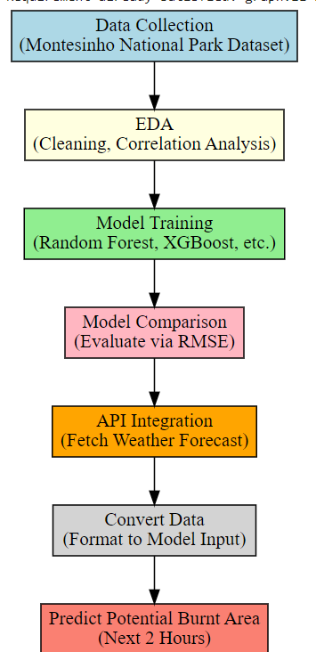

Fig 1. Flow diagram
The flowchart illustrates the end-to-end process of predicting the potential burnt area of an active forest fire. From the Montesinho Natural Park area, data are collected, and then exploratory data analysis, cleaning, and correlation checking take place. Five machine learning models: Random Forest, XGBoost, SVM, Linear Regression, and Neural Networks are trained and compared through RMSE scores. The best model is paired with real-time environmental data received from an API. These data are preprocessed and formatted to match the model input, with the final forecast of the burnt area into the following two hours for timely decision-making and resource optimization.

Methodology
This is chosen as it had proved to be widely recognised and used in the field of Forest Fire Area Burn research. It focuses on an area in the north-eastern part of Portugal called the Montesinho Natural Park and has records of fire incidents within this area. This dataset includes 517 data points and varied input variables involving various aspects of fire incidents and are primarily classified into 3 sub categories (Spatial, Temporal and Meteorological variables). Spatial Variables: ‘X’ and ‘Y’ : coordinates within the national park. Temporal Variables: ‘Day’ and ‘Month’ in encoded numerical format to help represent the seasonal as well as weekly patterns of fire occurrences. Spatial Variables: FFMC(Fine Fuel Moisture Control),DMC(Duff Moisture Code),DC(Drought Code),ISI(Initial Spread Index),Temperature(Relative Humidity),Wind speed. “Area” being the target variables which will be predicted using the regression models used. A Weather Forecasting API is to be used to get the weather forecast data of the region for the next 2 hours, on which, the trained model will make predictions upon. For Data Preprocessing, methods for data cleaning, normalisation, and data transformation methods are to be used to ensure that the data obtained is fit for training purposes.

Dataset Description
The dataset used in this study is the Forest Fires dataset [10], sourced from Kaggle’s Dataset. This dataset collects the forest fire data from the Montesinho National Forest Park in Portugal and is widely recognized and commonly used in forest fire area burn research. It contains 13 columns and 517 occurrences of the forest fire in that area.

1) Study Area
The dataset focuses on Montesinho Natural Park, located in the northeastern part of Portugal. It consists of 517 data points containing fire incident records with meteorological, spatial, and temporal variables.

2) Features in the Dataset
The dataset consists of three main types of variables: Spatial, Temporal and Meteorological. Spatial variables are the X and Y coordinates, which are locations in the grid system of the park. Temporal variables are day and month, both of which are numerically encoded as the time of fire occurrence. Meteorological variables comprise a set of fire-related weather variables, including FFMC (Fine Fuel Moisture Code), DMC (Duff Moisture Code), and DC (Drought Code), as indicators of different levels of fuel moisture and long-term dryness. Other variables are ISI (Initial Spread Index), temperature (°C), relative humidity (RH), and wind speed (km/h). The Target Variable: Area (in hectares) reflect the area of land affected by fire and is highly skewed.
A Weather Forecasting API [11] is integrated to retrieve real-time weather data for fire-prone regions, predicting possible fire spread areas for the next two hours.

Data Preprocessing
To ensure data quality and optimize model performance, several preprocessing steps were implemented:

Handling Missing & Duplicate Data
The dataset was checked for missing values and duplicates. Any inconsistencies in data were removed.

Log Transformation of Target Variable
Since the burned area (Area) is highly skewed, a log transformation is applied to stabilize variance and normalize distributions:
$${log-area=log}_{10}\left(area+1\right)$$
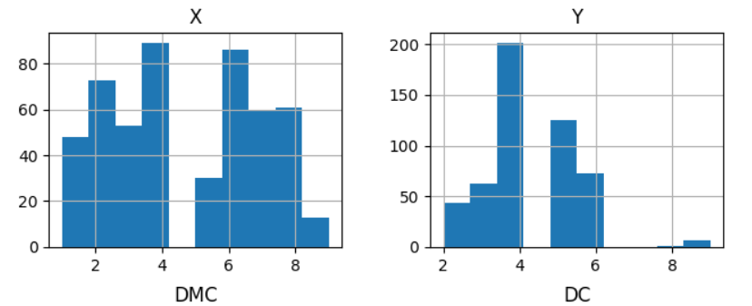
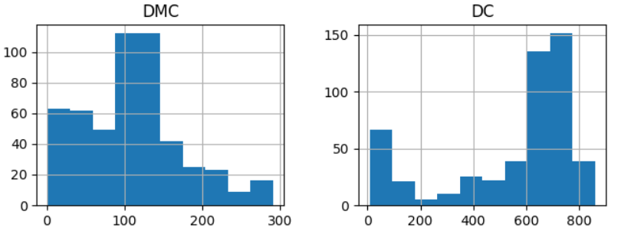
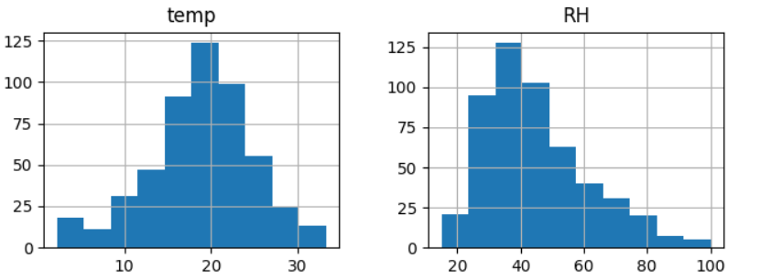
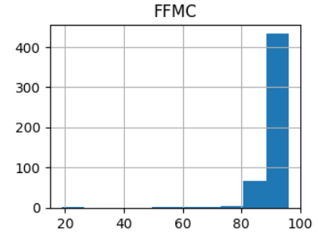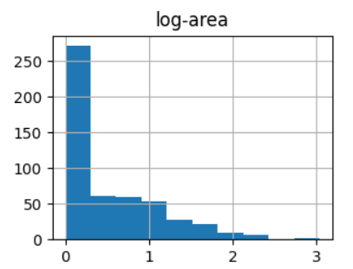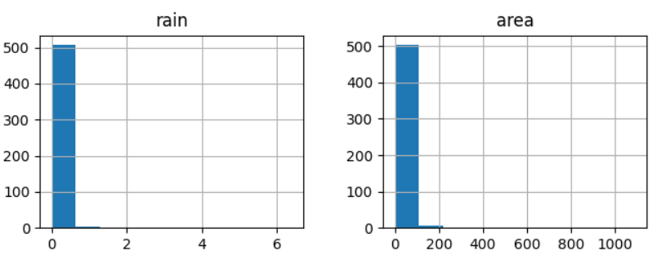
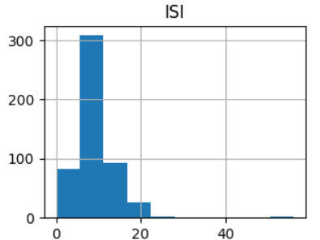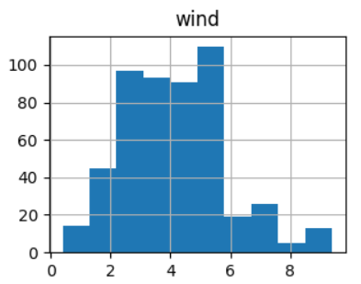
Fig 2. A histogram of all columns after log transformation

Feature Scaling (Normalization)
To bring all numerical values to the same scale, Min-Max Normalization is applied:
$$x^{'}=\frac{x-\min\left(x\right)}{\max\left(x\right)-min⁡(x)}$$
[ x′ = scaled feature value.]
[min(x),max(x) minimum and maximum values of the feature.]

Encoding Categorical Variables
Day and Month values are encoded using One-Hot Encoding to allow models to capture trends effectively.
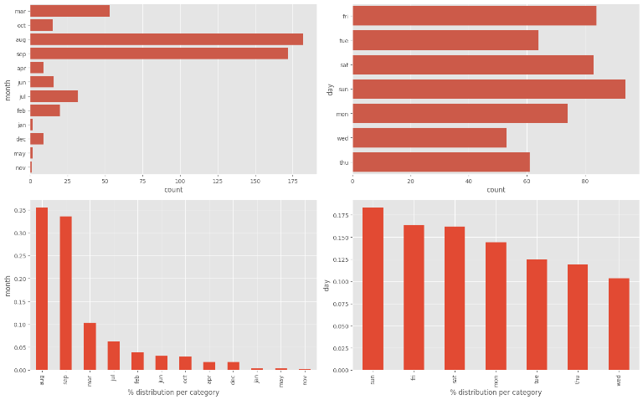
This ensures the models understand time-based patterns.
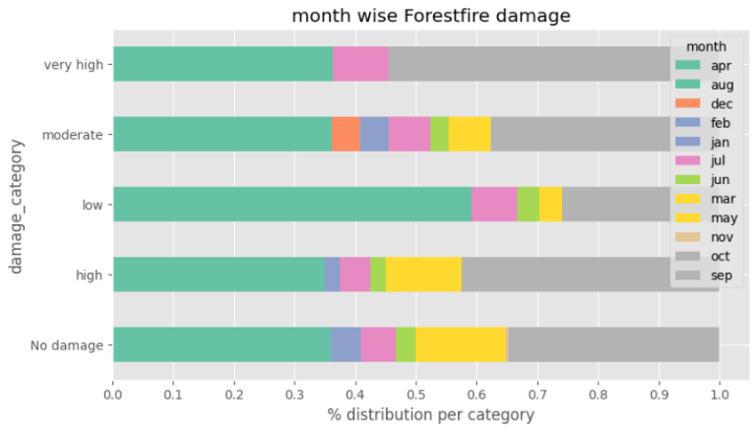
Fig 3. Distribution per Category

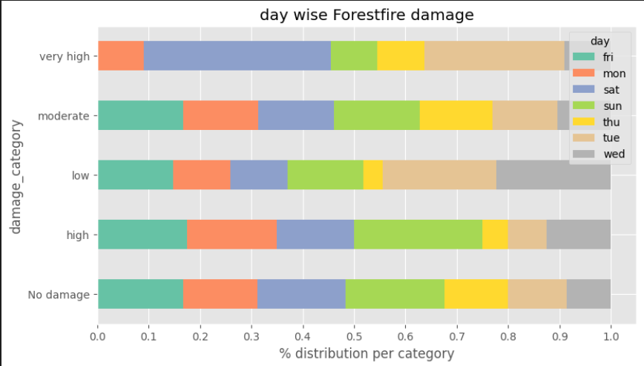
Fig 4. Distribution of damage per category each month and day of week

Exploratory Data Analysis (EDA)
Before model training, EDA was performed to understand data relationships.

Correlation Analysis
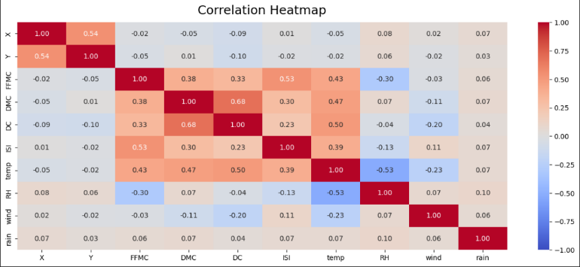
A heatmap was plotted to analyze relationships between meteorological variables and burned area. The correlation coefficient r is calculated as:
$$r=\frac{\sum_{i=1}^{n}{{(x}_{i}-\overline{x})(y_{i}-\overline{y})}}{\sum_{i=1}^{n}{{{(x}_{i}-\overline{x})}^{2}{(y_{i}-\overline{y})}^{2}}}$$

Fig 5. Correlation Heatmap of all features

Scatter Plots
Temperature vs Burned Area → Higher temperatures generally correspond to larger burned areas.
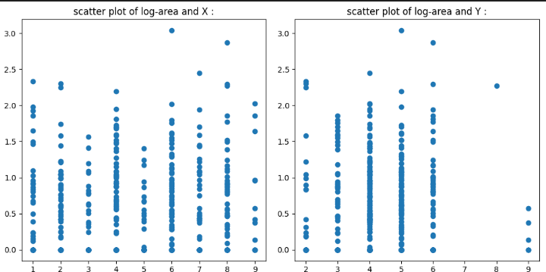
Wind Speed vs Burned Area → Higher wind speeds can cause faster fire spread.

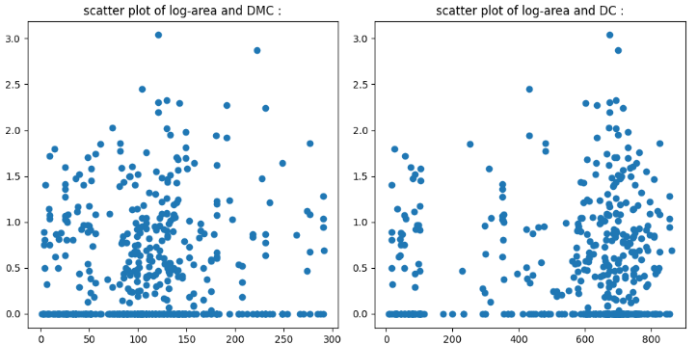
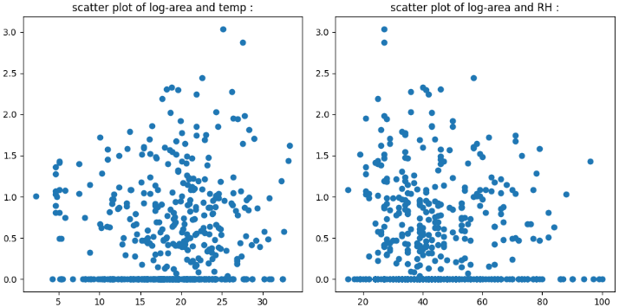
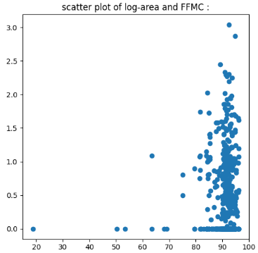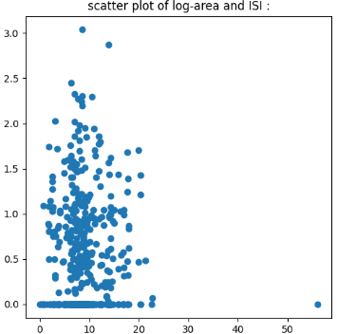
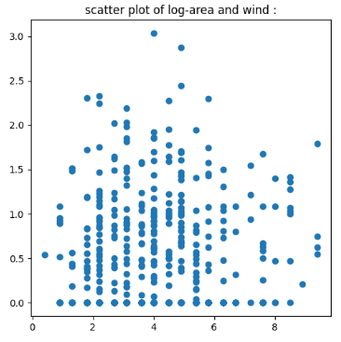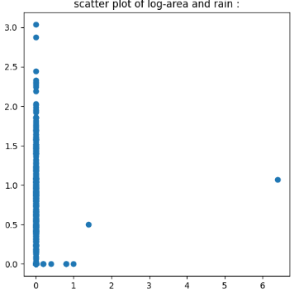
Fig 6. Scatterplot of log area vs all individual features

Skewness and Kurtosis Analysis
Skewness: Measures the asymmetry of the distribution. A positive skew suggests the presence of extreme values (large fire events). Kurtosis: Measures the tail heaviness of the distribution, indicating outliers' influence. The KDE plot below illustrates the non-normal nature of the burned area variable:
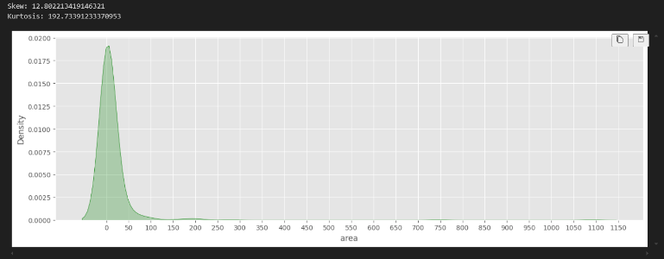
Fig 7. Density vs area
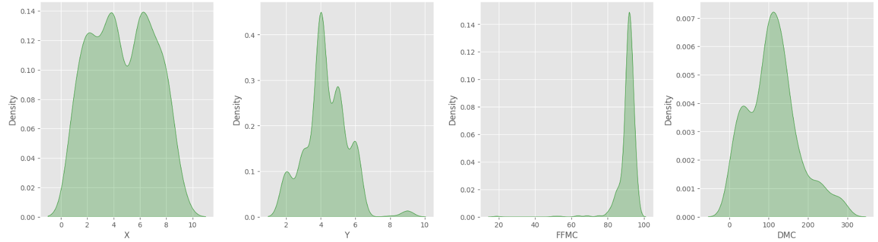
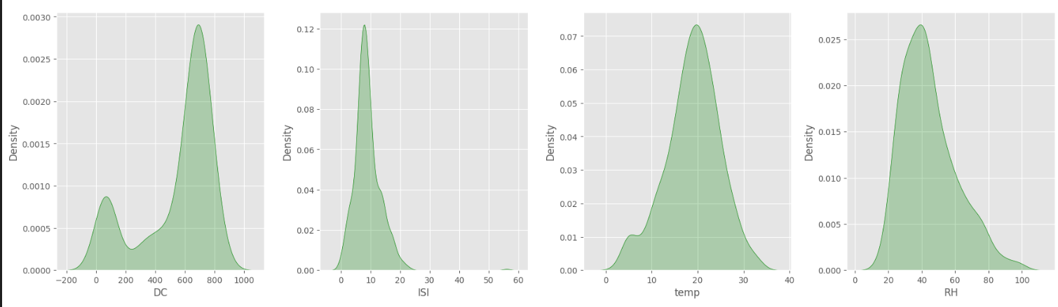
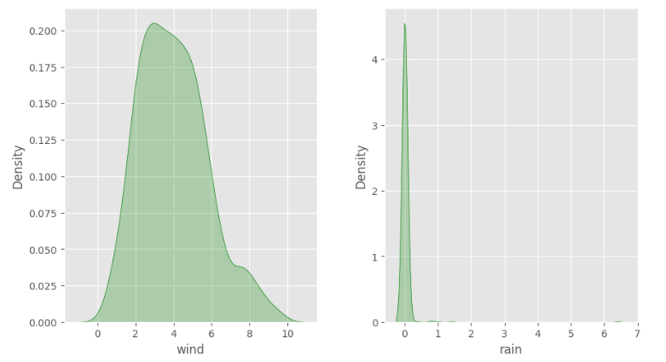
Fig 8. Density vs each Feature

Box Plot Analysis of Burned Area
To further explore the distribution of the burned area (area), a box plot was generated. This visualization highlights the presence of outliers, which are evident in the dataset due to extreme fire incidents affecting significantly larger areas.
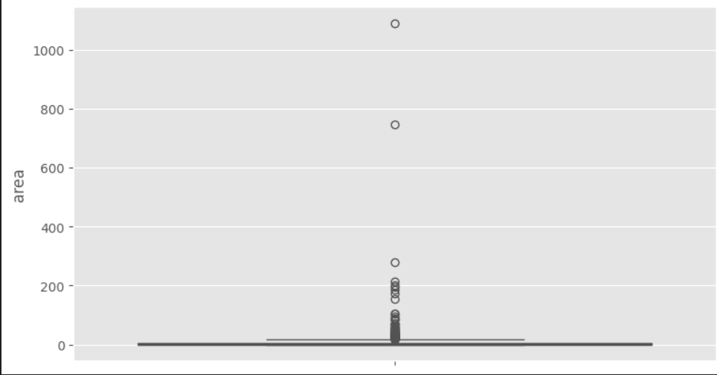
Fig 9. Boxplot for area

Numerical Feature Analysis with Fire Damage Categories
To examine the relationship between numerical features and the burned area (area), swarm plots (for spatial variables X and Y) and scatter plots (for other numerical features) were generated. These visualizations highlight how different meteorological and spatial factors influence fire spread, categorized by damage severity as no damage, low, moderate, high and very high.
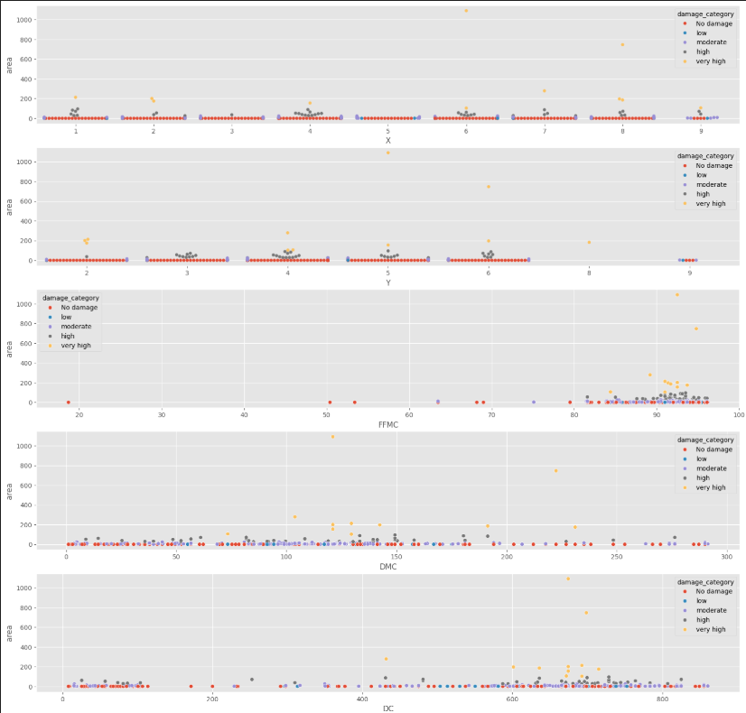
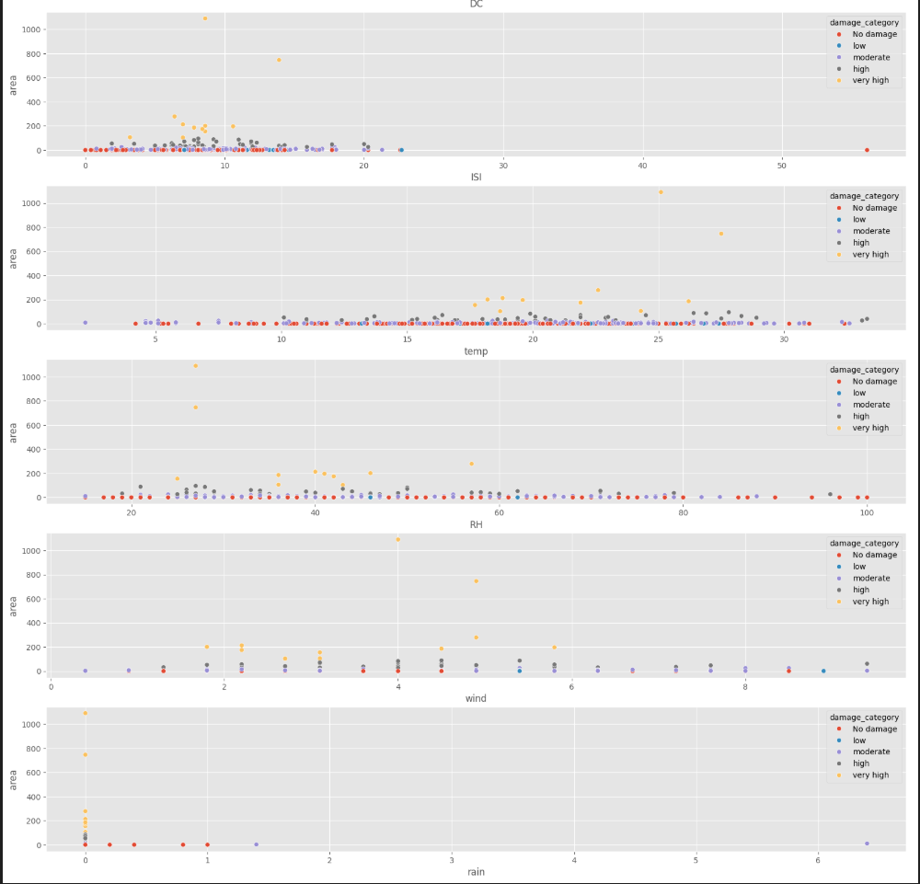
Fig 10. Area vs each feature categorization by damage severity

Pairwise Relationship Analysis of Selected Features
A pair plot was generated to visualize the pairwise relationships between the selected numerical features, with fire damage categories highlighted using color. This helps in understanding correlations and identifying potential patterns among different meteorological and spatial variables.
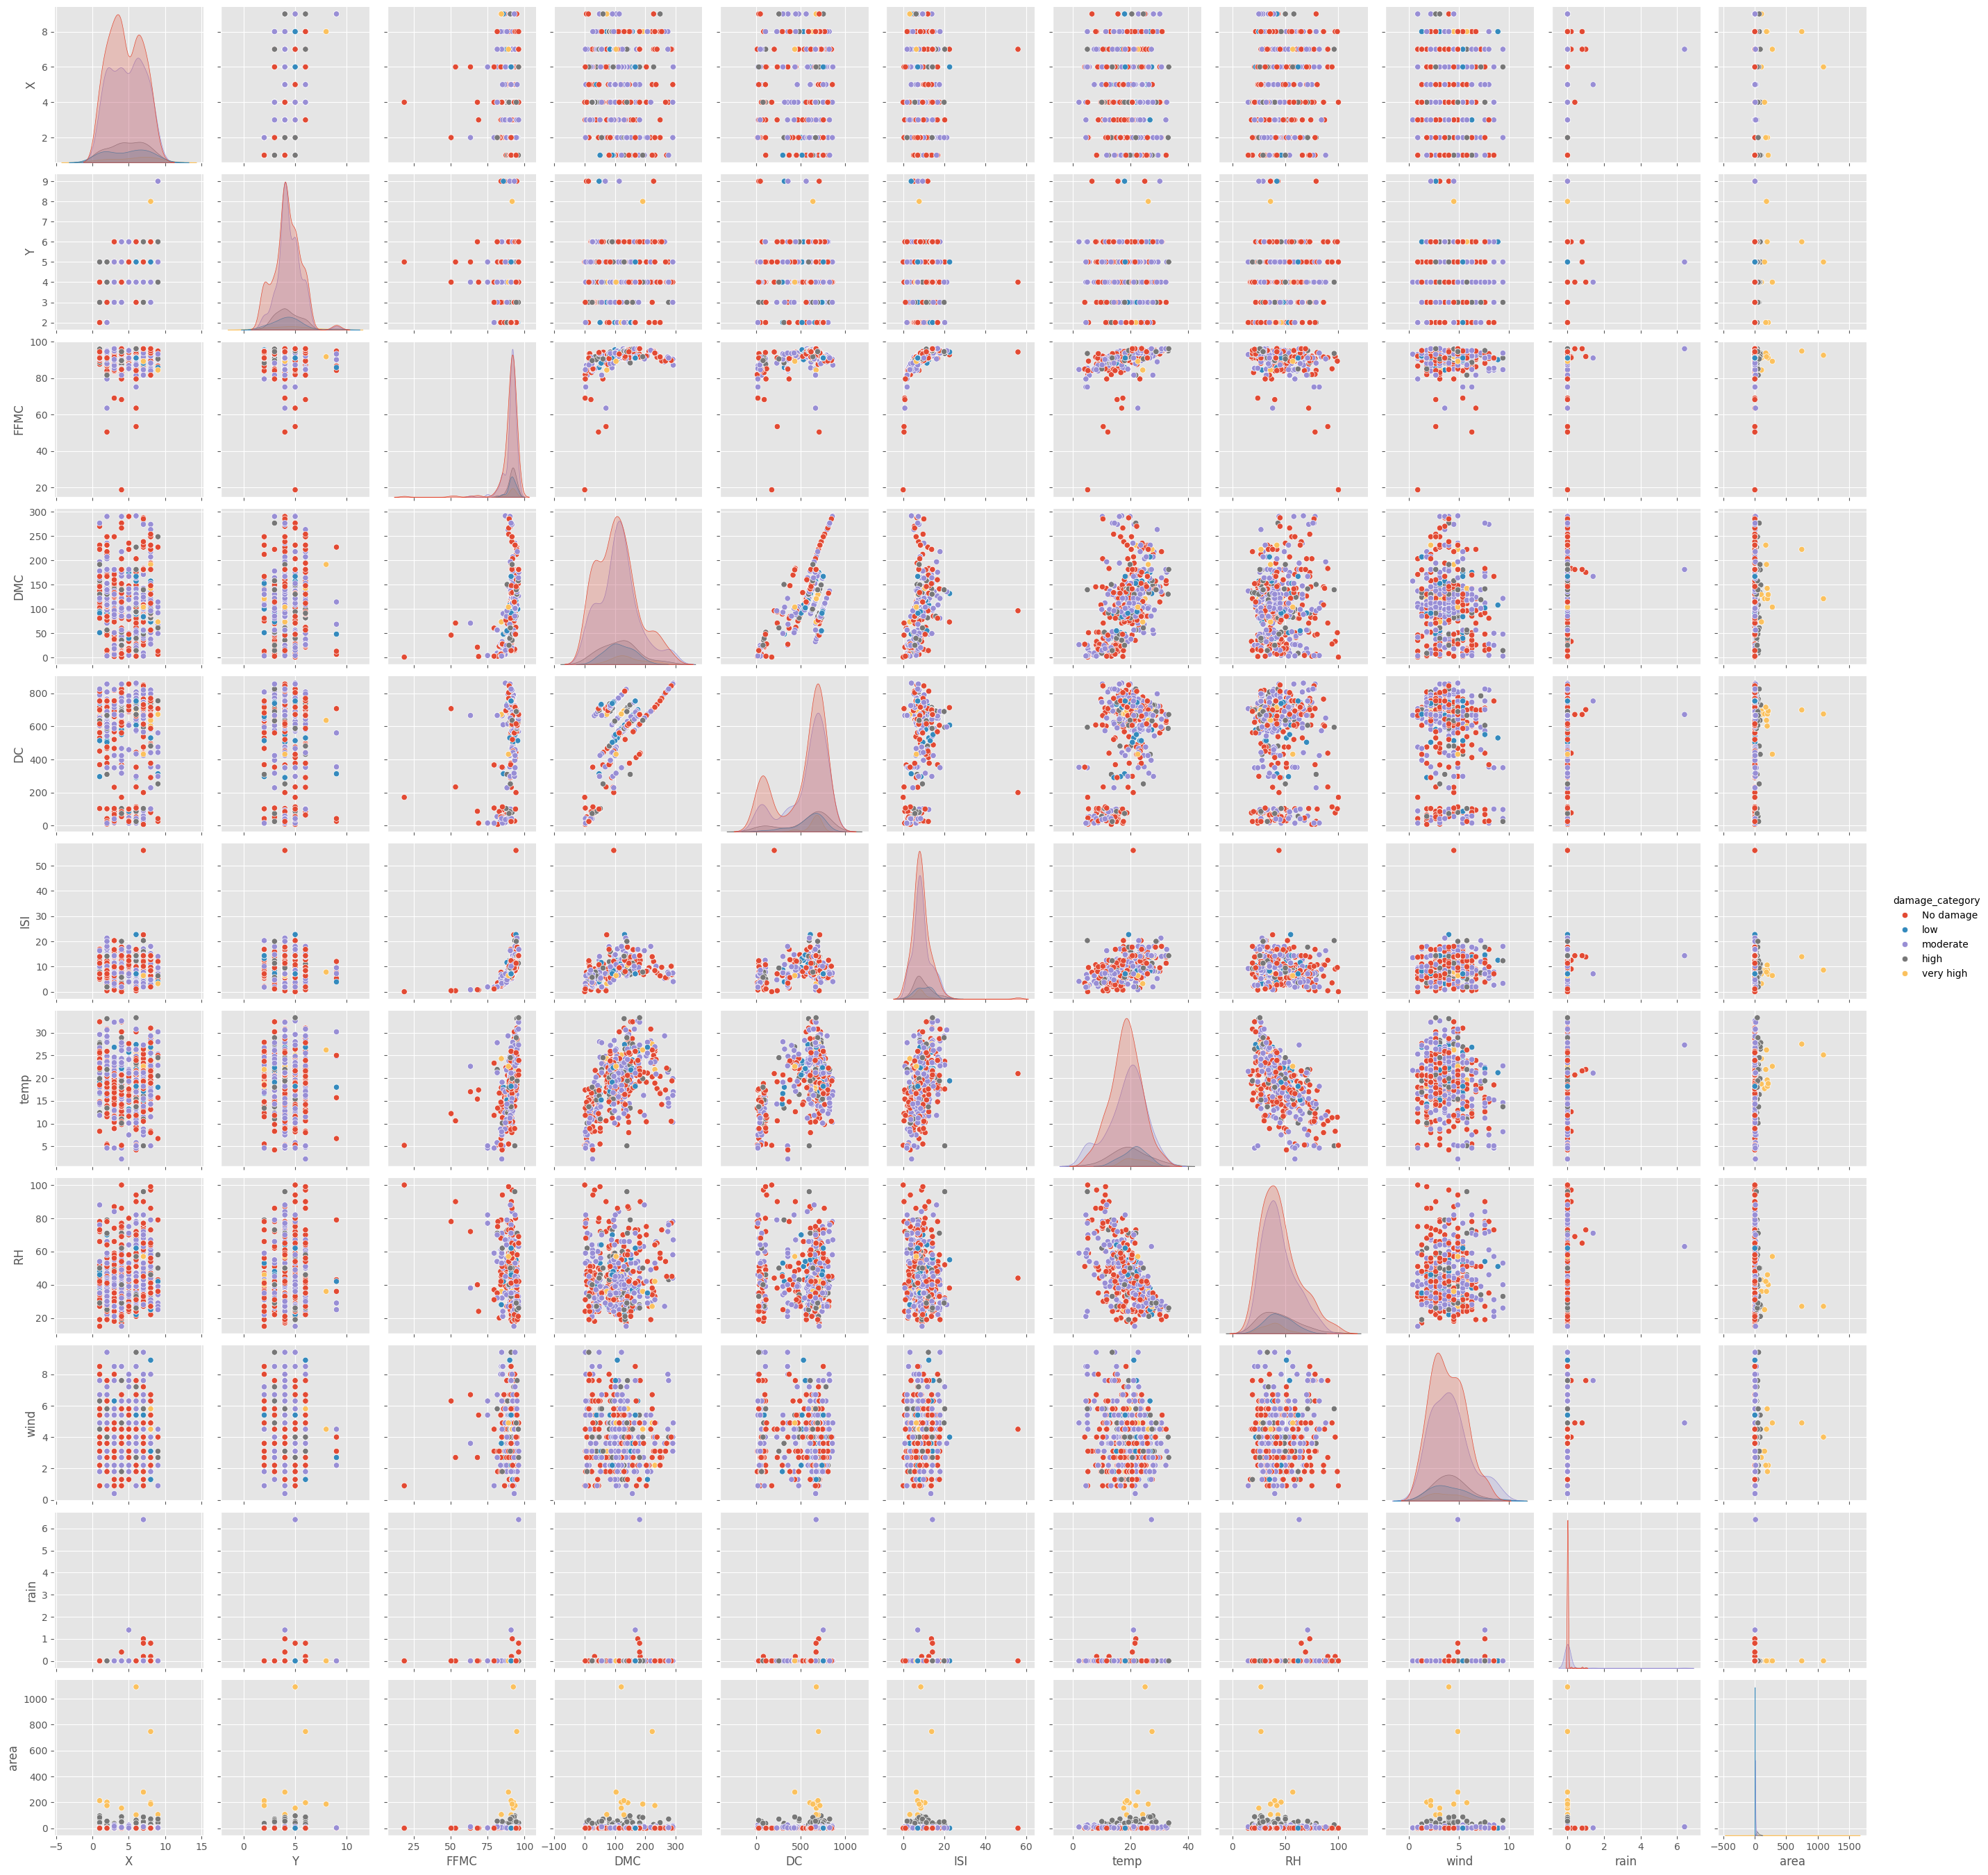
Fig 11. Pairplot and damage category plotting

Machine Learning Models Used
Since the dataset is relatively small, traditional machine learning models were chosen for prediction. The dataset was split in the ratio 75:25 for training purpose.

Random Forest Regressor
A Random Forest model was used, which is an ensemble of decision trees. The prediction is computed as:
$$\hat{y}=\frac{1}{T}\sum_{t=1}^{T}{f_{t}(x)}$$
[T = number of trees.]
$[f_{t}(x)$ = prediction from tree t]
The best parameters obtained by Grid Search were 'max_depth': 10, 'max_leaf_nodes': 2, 'min_samples_leaf': 5, 'min_samples_split': 5

Linear Regressor

A Linear Regression model was used to estimate the relationship between input features and target variables by fitting a linear equation. It is computed as:

ŷ = β₀ + Σ (from j = 1 to p) βⱼ * xⱼ

[ ŷ = predicted output]
[ β₀ = intercept term]
[βⱼ = coefficient for feature j]
[xⱼ = input feature j]
[p = number of features]

Neural Networks
A Deep Neural Network model consisting of multiple fully connected layers. It learns hierarchical representations of input features through multiple transformations. The prediction is computed as:
ŷ = f (x; θ)
[ ŷ = predicted output]
[ x = input features]
[ θ = model parameters (weights and biases)]
[ f = composite function formed by stacked layers]
The model architecture includes:
Input layer: Dense(100), input_dim = 27, activation = ReLU
Hidden layers
Output layer: Dense (1)

Gradient Boosting Regressor
Gradient Boosting is a sequential ensemble learning technique that minimizes the error function:
$L\left(y,F(x\right))=\frac{1}{2} \sum_{i=1}^{n}{{(y_{i}-F(x_{i}))}^{2}}$
$[y_{i}$ = actual burned area.]
$[F(x_{i})$ = predicted burned area.]
The best parameters found were 'colsample_bytree': 0.8, 'gamma': 5, 'max_depth': 1, 'min_child_weight': 10, 'subsample': 0.6

Support Vector Regressor
A Support Vector Regression model finds a function that deviates from the actual targets by a value no greater than ε for training data, while being flat. The prediction is computed as:
ŷ = w · x + b
[ ŷ = predicted continuous value]
[ w = weight vector]
[ x = input feature vector]
[ b = bias term]

Model Evaluation Metrics
The models were evaluated using:

Mean Squared Error (MSE)
$MSE=\frac{1}{n}\sum_{i=1}^{n}{{(y_{i}-\overline{y})}^{2}}$

Root Mean Squared Error (RMSE)
$RMSE= \sqrt{\frac{\sum_{i=1}^{n}{{(y_{i}-\overline{y})}^{2}}}{n}}$

Weather Forecast Integration
To extend predictive capabilities, a Weather Forecast API fetches real-time weather data with the timestamp, temperature, humidity, windspeed and rain for the next two hours. This data is formatted to match the model's input features and maybe fed into the trained model to predict the potential fire spread. Parameters such as FFMC, DMC, DC and ISI used for model evaluation are evaluated using the simple formulas given below:

FFMC=85+(0.5×Temperature)−(0.1×Humidity)+(0.05×Wind Speed)−(0.2×Rainfall)

DMC=20+(0.3×Temperature)−(0.05×Humidity)−(0.1×Rainfall)

DC=100+(0.5×Temperature)−(0.1×Rainfall)

ISI=0.2×[0.923×Wind Speed^0.5​×(1+0.18×Wind Speed)×(0.023×FFMC)]

Result and conclusion
The REC (Regression Error Characteristic) curve shows how well Random Forest, Neural Network, and XGBoost models predict burnt area under varying degrees of error tolerance.
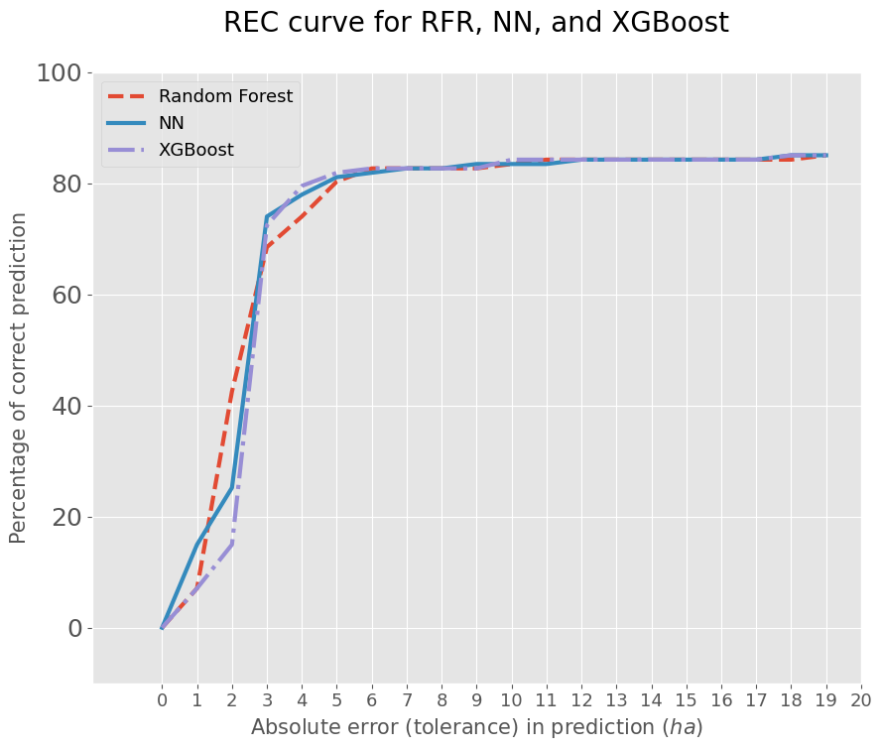
Fig 12. REC curve visualization
With an increase in absolute error tolerance (x-axis), correct prediction percentage (y-axis) is also seen to rise, at which point all three models converge around 85% accuracy above a tolerance of 5 hectares. Such behavior indicates good performance with stability for all models. The models show a steep increment of prediction accuracy at lower error levels, reflecting their good adaptation to tight tolerances.
The performance of all the various ML models applied is mentioned in the table below:
Model | MSE | RMSE
Linear Regression | 0.3880 | 0.6229
Support Vector Machine | 0.3937 | 0.6275
Neural Network | 0.3906 | 0.6250
Random Forest Regressor | 0.3789 | 0.6156
XGBoost Regressor | 0.3767 | 0.6138
Table 1. Comparative analysis for different models used
Real-Time Weather Integration and Feature Mapping
The Novel component for this study is the use and Integration of Weather Forecast API, to obtain the real time weather attributes – timestamp, temperature, humidity, wind speed and rainfall for the are of interest. These raw weather inputs are used to compute additional fire-behavior related indices like: FFMC, DMC, DC, ISI.
All these attributes are passed into trained prediction model to generate near-instant insights on potential area burn within the next 2 hour to allow real time decision-making.
This paper thus proposes an effective approach to predict wildfire spread using a blend of historical training data and life forecast information. Among all the tested models, Random Forest and XGBoost have outperformed in terms of RMSE scores. The integration of real-time weather forecast allows for near-real0time prediction thus making the solution practical for being deployed in wildfire-prone regions for efficient resource management.

Future Work
Future enhancements to this research involve incorporating deep learning techniques like LSTM and CNN models to more effectively learn spatial and temporal relationships in fire dynamics. Enlarging the dataset with more datapoints features such as air pressure, solar radiation, and soil moisture could greatly improve the model's robustness and accuracy. Integrating real-time fire detection based on IoT sensor networks would make the system feasible for real-world implementation by facilitating immediate response functions. Additionally, using explainability methods like SHAP (Shapley Additive Explanations) will facilitate model outputs interpretation, with transparency in the decision-making process. Finally, scenario analysis aimed at the long-term impacts of climate change on fire behaviour can provide useful inputs for future prevention and resource management.

References
- X. Sun et al., "A Forest Fire Prediction Model Based on Cellular Automata and Machine Learning," in IEEE Access, vol. 12, pp. 55389-55403, 2024, doi: 10.1109/ACCESS.2024.3389035.
- J. Ye, J. Cui and Y. Xu, "A Dynamic Forest Fire Spread Model Based on Cellular Automata Principles," 2023 IEEE Smart World Congress (SWC), Portsmouth, United Kingdom, 2023, pp. 1-8, doi: 10.1109/SWC57546.2023.10448722.
- K. Nampoothiri, K. N. U. Maheshwari, S. Sundar and T. N. Padmini, "Fire spread analysis and Fire detection using CNN," 2024 3rd International Conference on Artificial Intelligence For Internet of Things (AIIoT), Vellore, India, 2024, pp. 1-6, doi: 10.1109/AIIoT58432.2024.10574694.
- Bhatt, S., Chouhan, U. An enhanced method for predicting and analysing forest fires using an attention-based CNN model. J. For. Res. 35, 67 (2024). https://doi.org/10.1007/s11676-024-01717-7
- T. Sawetsuthipan and P. Wongchaisuwat, "Forecasting Burned Areas of Wildfires: A Case Study of Mae Hong Son Province in Thailand," 2023 4th International Conference on Computers and Artificial Intelligence Technology (CAIT), Macau, Macao, 2023, pp. 52-56, doi: 10.1109/CAIT59945.2023.10469354.
- S. Lin and H. Huang, "Spatial Extension of 3PGmix to Predict Post-Fire Forest Regrowth and Response of Climate Change in High Severity Burned Area," IGARSS 2023 - 2023 IEEE International Geoscience and Remote Sensing Symposium, Pasadena, CA, USA, 2023, pp. 3379-3382, doi: 10.1109/IGARSS52108.2023.10281649.
- David A. Wood, Prediction and data mining of burned areas of forest fires: Optimized data matching and mining algorithm provides valuable insight, Artificial Intelligence in Agriculture, Volume 5,2021,Pages 24-42,ISSN 2589-7217,https://doi.org/10.1016/j.aiia.2021.01.004
- Meraliyev, Bakhtiyor & Kongratbayev, Kurmangazy. (2020). Applying machine learning models for predicting forest fires in Australia and the influence of weather on the spread of fires based on satellite and weather forecast data.. Proceedings of International Young Scholars Workshop. 9. 10.47344/iysw.v9i0.187.
- Liu, S., Cao, L., Lin, C. et al. Fire spread prediction model based on multi-scale convolutional neural network. Multimed Tools Appl (2024). https://doi.org/10.1007/s11042-024-20400-x
- Archive.(https://www.kaggle.com/datasets/elikplim/forest-fires-data-set ).
- https://www.weatherapi.com/

